**MEMBER**

**REPORT**

**[CAMBODIA]**

ESCAP/WMO Typhoon Committee

13th Integrated Workshop

Chiang Mai, Thailand

5-9 November 2018

**CONTENTS**

**I. Overview of tropical cyclones which have affected/impacted**

**Member’s area since the last Committee Session**

* Meteorological Assessment (highlighting forecastingissues/impacts).

Cambodia is located in mainland Southeast Asia, bordering Thailand, Laos, Vietnam and the Gulf of Thailand.

During the season of year 2017 to 2018, there was no direct impacted by Typhoon or any Cyclone on the Country. However the potential of typhoons were generally indirect impacted to the Country by linked to the Southwest Monsoon wind and the Inter Tropical Convection Zone or Monsoon Trough.

The major factor of Severe Weather that impacted the Country in 2018 was Thunderstorm, Strong Southwest Monsoon and in direct impact from Tropical Cyclone; that produced Heavy Rainfall caused to flood and flash flood in some part of the country such coastal area and several provinces in low-lying area, and particularly lightning caused to

In the early June 2018, Cambodia was indirected impact by Tropical Storm Ewiniar,

-------------------------------------------------

Lightning 2018

The Nation News

October 18, 2018

## Lightning strike killed four, injured three people

Lightning strike in Preah Sihanouk’s Prey Nob district killed one person and injured three others on Wednesday, while another lightning strike in Banteay Meanchey’s Phnom Srok district has killed three people.

A report said during the first nine months of this year, lightning has killed more than one hundred people and injured dozens.

Pov Chan, Ou Okhna Heng commune police chief, yesterday said the lightning struck in the afternoon, killing 35-year-old driver Lem Pronh, while injuring three others.

“The four victims were clearing a nearby forest about six to seven kilometres away from Ou Okhna Heng village,” Mr Chan said. “They were in a mountainous area when suddenly the sky began to show signs of rain. Lightning then struck and killed one of them, while one was seriously injured and the two others suffered only minor injuries.”

He noted that the three injured were sent to hospital in the village and continued treatment at home. A funeral was held for Mr Pronh.

Meanwhile, in Banteay Meanchey, three farmers were killed while tending to their herd at Srah Chik commune’s Srah Chik village.

Chem Thom, a Phnom Srok deputy district police chief, yesterday said the strike occurred at about 3:30pm during rain.

“There was rain and lightning. The three people were tending to their cows and looked for shelter at a rice field when lightning struck, hitting all three,” Mr Thom said. “They all died at the scene.”

He noted that the victims were identified as farmers Mak Yoeuy, Moeun Samet and Prel Chhenge.

Keo Vy, a National Committee for Disaster Management spokesman, said lightning strikes have killed 96 people while injuring 63 others.

Mr Vy added that most of the victims hailed from Kampong Thom, Pursat, Banteay Meanchey, Oddar Meanchey and Preah Sihanouk provinces.

“The rate of lightning incidents this [so far] year increased when compared to the whole year last year. About 70 to 80 people died in 2017,” he said. “This year’s [lightning] incidents occurred due to a change in weather patterns. So many areas have been affected by storms. There were also different pressures, increasing the risk of lightning strikes.”

Mr Vy said farmers and villagers should refrain from working in fields during rain, adding that phones, radios and television sets should be powered off at home.

He noted that metal objects and high trees are prone to lightning strikes.

Phnom Penh Post

Publication date 21 May 2018 | 10:31 ICT

The spokesman for the National Committee for Disaster Management (NCDM) said that through Sunday, lightning has caused over 90 casualties, including more than 50 deaths, while storms have damaged or destroyed more than 2,000 residences and killed roughly 50 head of cattle, as the rainy season began with a fury.

On Thursday, five people, including a 4-year-old, were killed instantly in a lightning strike in Koh Kong, according to AFP. And on Sunday afternoon in Sreung commune in Kampong Thom province’s Brasat Sambo district, three people were injured after lightning struck a tree, according to Chab Pun, the commune’s chief of police.

NCDM spokesman Keo Vy said on Sunday that lightning has already killed 51 people – up from 41 in the same period last year – injured 40 others and killed 53 cows and buffalo. Meanwhile storms have been responsible for at least two additional deaths and 25 injuries. Storms have also damaged 1,648 homes and destroyed 394 others. Schools, commune halls, hospitals and police stations around the country have also experienced damage.

“When it rains, and the storm comes and lightning is present, it is dangerous and puts people’s lives in danger; but farmers living in rural areas are happy to work when it rains, and this is a point of concern,” Vy said.

Pun told The Post on Sunday that at 4:40pm, lightning struck a coconut tree and hurt three people under their house near the tree. They fainted and were sent to hospital.

Vy said the government had conducted lightning-education seminars to warn people to avoid sheltering under trees and standing in water, According the AFP.

---------------------------

**Publication date 15 May 2018 | 11:06 ICT**

Twelve people, including two police officers, were struck by lightning in Banteay Meanchey and Oddar Meanchey provinces on Sunday afternoon, killing four people and leaving several seriously injuredThe National Committee for Disaster Management has said that since early 2018 until Sunday, 38 people have died and 27 have been injured by lightning strikes in the Kingdom.

Ath Khem, Banteay Meanchey provincial police chief, told The Post on Monday that the two injured police officers are Roeun Pally and Pav Saran from Banteay Meanchey. They have both been sent to Thmor Puok District Referral Hospital.

Khem said it rained heavily and lightning struck both the police officers while they were sitting writing a report inside a police post.

He also said that in Tbaeng Chas village, Banteay Meanchey, lightning struck five people, with two being killed and three hurt. The wounded victims were sent to Thmor Puok District Hospital.

For the five struck by the lightning, some of them were minding cattle and some were going to their rice field.

“I visited the victims in the hospital and the doctor said that they are safe, but they need to be monitored,” he said.

Khol Phil, Banteay Ampil district deputy police chief in Oddar Meanchey, said two men died and three others were injured when they were hit by lightning as they were ploughing a rice field while it was raining.

“They [the victimes] were ploughing the land and when it started raining, they took shelter under a tree where they were hit,” Phil said, confirming that the injured victims were taken to hospital while the bodies of those who were killed were returned to their families for a traditional funeral.

Keo Vy, spokesman for the National Committee for Disaster Management, stated that at least 38 people have been killed, 27 injured and 26 cattle have been killed, with 11 houses being damaged by lightning between early 2018 and Sunday. The provinces where lightning have resulted in deaths and injuries are Prey Veng, Pursat, Battambang, Banteay Meanchey, Kampong Thom, Koh Kong and Kratie.

“For this case, most of them happened in the afternoon or evening while farmers were busy ploughing, planting and minding the cattle, and these tasks prevent them from following the advice to reduce the risks from lightning,” Vy said.

**Tropical Storm Ewiniar**

**[Tropical Storm Ewiniar](https://en.wikipedia.org/wiki/Tropical_Storm_Ewiniar_(2018))**[was a weak tropical cyclone that affected South China in early June of 2018. The storm brought torrential rainfall and landslides over in the southern provinces. Ewiniar, as the fourth named storm of the 2018 Pacific typhoon season, firstly developed as a tropical depression just to the west of the Philippines on June 2. Maintaining its intensity for a few days in the South China Sea, the system moved north just near Hainan island where it intensified into a tropical storm on June 6. The storm made landfall shortly thereafter and rapidly weakened into a remnant low on June 9, before dissipating four days later.](https://en.wikipedia.org/wiki/Tropical_Storm_Ewiniar_(2018))

 low-pressure area developed into a tropical depression over the [South China Sea](https://en.wikipedia.org/wiki/South_China_Sea) on June 2.[[33]](https://en.wikipedia.org/wiki/2018_Pacific_typhoon_season#cite_note-33)[[34]](https://en.wikipedia.org/wiki/2018_Pacific_typhoon_season#cite_note-34) Later that day the JTWC followed suit and designated the system as *05W*.[[35]](https://en.wikipedia.org/wiki/2018_Pacific_typhoon_season#cite_note-35) 05W meandered in a westward direction until it curved northward and after three days, the JTWC upgraded the system to a tropical storm.[[36]](https://en.wikipedia.org/wiki/2018_Pacific_typhoon_season#cite_note-36)The JMA did the same three hours later early on June 6, naming it *Ewiniar*.[[37]](https://en.wikipedia.org/wiki/2018_Pacific_typhoon_season#cite_note-37) Shortly thereafter, Ewiniar made landfall over [South China](https://en.wikipedia.org/wiki/South_China). Ewiniar maintained its intensity while over land until the JTWC issued its final advisory late on June 7.[[38]](https://en.wikipedia.org/wiki/2018_Pacific_typhoon_season#cite_note-38) The JMA, however, tracked the system until early on June 9, when Ewiniar had weakened into a tropical depression and degenerated into a remnant low.[[39]](https://en.wikipedia.org/wiki/2018_Pacific_typhoon_season#cite_note-39) However, Ewiniar's remnant moved out to sea and continued to persist, before dissipating on June 13.

**[Tropical Storm Son-Tinh](https://en.wikipedia.org/wiki/Tropical_Storm_Son-Tinh_(2018))**[, known in the Philippines as](https://en.wikipedia.org/wiki/Tropical_Storm_Son-Tinh_(2018))**[Tropical Storm Henry](https://en.wikipedia.org/wiki/Tropical_Storm_Son-Tinh_(2018))**[, was a relatively weak but very deadly tropical cyclone that devastated Vietnam and Laos in July 2018. Son-Tinh originated from an area of low pressure over the Philippine Sea on July 15, 2018. Moving quickly westwards, Son-Tinh strengthened to the ninth tropical storm of the annual typhoon season on July 17. Intensifying only slightly while crossing the South China Sea, Son-Tinh made its first landfall over Hainan Island on July 18. After emerging into the Gulf of Tonkin, Son-Tinh restrengthened before making its second landfall as a tropical storm in Northern Vietnam on July 19. Once inland, Son-Tinh weakened into a low pressure area as it slowed and made a clockwise loop. The remnants of Son-Tinh then emerged back over water and regenerated into a tropical depression late on July 21.](https://en.wikipedia.org/wiki/Tropical_Storm_Son-Tinh_(2018))

An area of low-pressure strengthened into a tropical depression on July 15, to the northwest of [Manila](https://en.wikipedia.org/wiki/Manila), [Philippines](https://en.wikipedia.org/wiki/Philippines).[[57]](https://en.wikipedia.org/wiki/2018_Pacific_typhoon_season#cite_note-11W1-57) The JTWC designated it as *11W* while the PAGASA named it *Henry*.[[57]](https://en.wikipedia.org/wiki/2018_Pacific_typhoon_season#cite_note-11W1-57) As the system moved in a fast westward direction, the system gradually intensified and was declared a tropical storm by July 17, with the JMA naming it as *Son-Tinh* as its convective structure improved.[[58]](https://en.wikipedia.org/wiki/2018_Pacific_typhoon_season#cite_note-58) Although from thereafter, Son-Tinh slightly weakened as it neared [Hainan](https://en.wikipedia.org/wiki/Hainan) island while experiencing moderate shear.[[59]](https://en.wikipedia.org/wiki/2018_Pacific_typhoon_season#cite_note-59) During the next day, however, Son-Tinh slightly intensified over in the [Gulf of Tonkin](https://en.wikipedia.org/wiki/Gulf_of_Tonkin) due to warm sea-surface temperatures before it made landfall in northern [Vietnam](https://en.wikipedia.org/wiki/Vietnam).[[60]](https://en.wikipedia.org/wiki/2018_Pacific_typhoon_season#cite_note-60) Both agencies issued their final warning on Son-Tinh on July 19 as the system had weakened back into an area of low-pressure embedded by the [monsoon](https://en.wikipedia.org/wiki/Monsoon).[[61]](https://en.wikipedia.org/wiki/2018_Pacific_typhoon_season#cite_note-61) However, the JTWC continued to track the system's remnant low for another two days, before it finally dissipated.[[62]](https://en.wikipedia.org/wiki/2018_Pacific_typhoon_season#cite_note-11Wtrack-62)

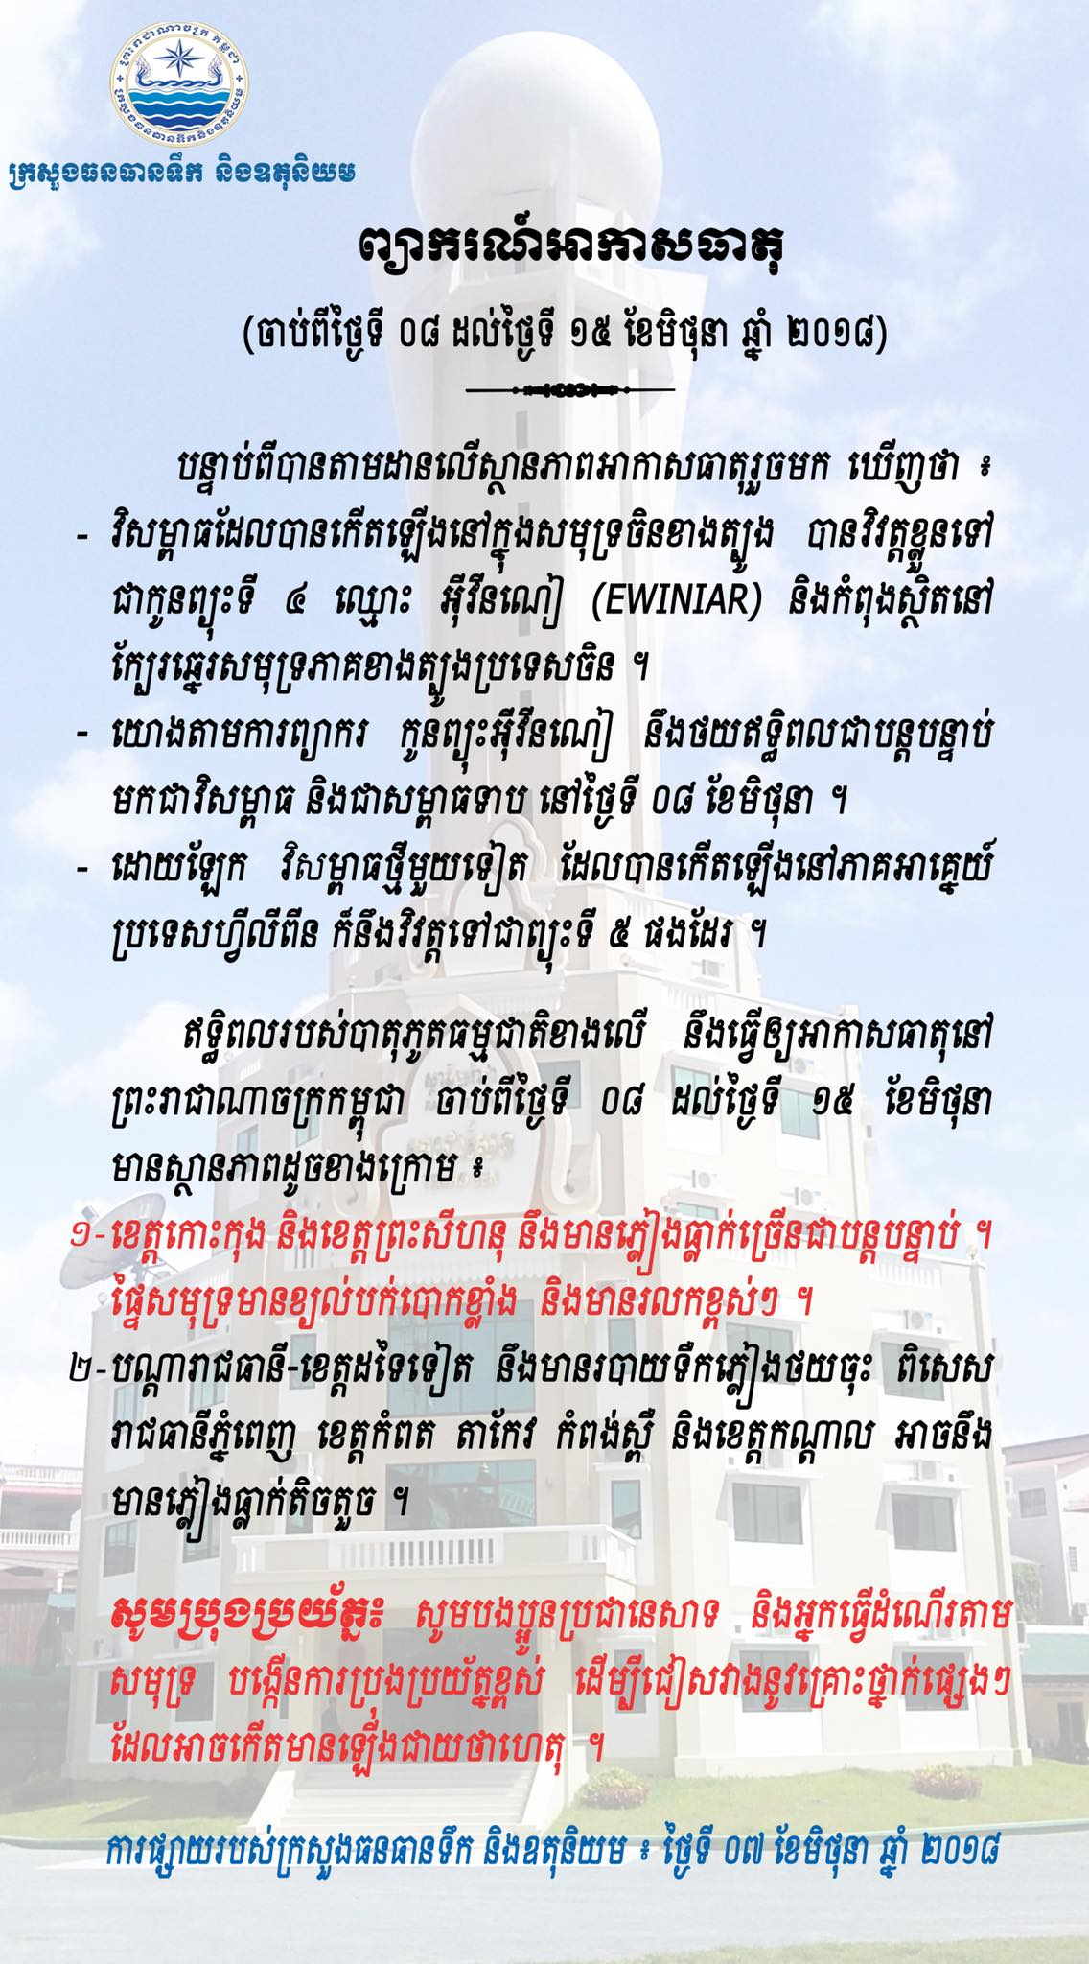

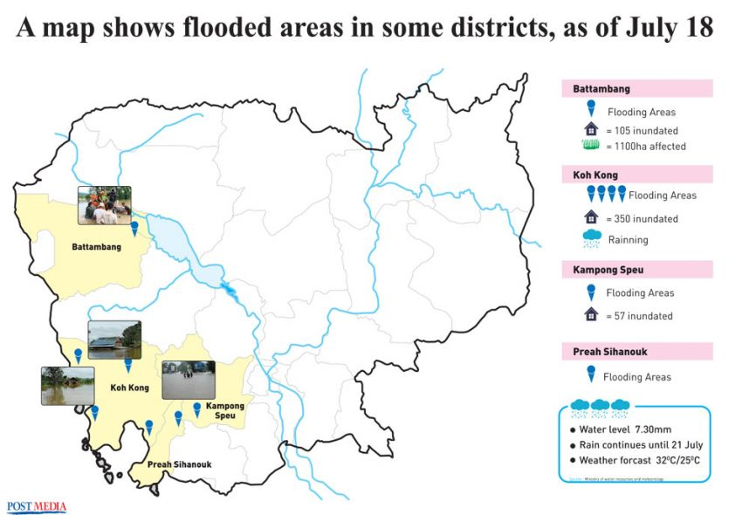

## Serious flooding across country

[Voun Dara](https://www.phnompenhpost.com/author/voun-dara/104908) | Publication date 19 July 2018 | 10:46 ICT

The Kampong Speu provincial Committee for Disaster Management on Wednesday issued an alert after non-stop heavy rain caused widespread flooding.

In Koh Kong province, authorities are working with the disaster committee and the Cambodian Red Cross to assist those affected after more than 350 homes were inundated.

In Battambang, the provincial department of agriculture said that, as of Wednesday, 1,100 hectares of paddy fields in Ek Phnom district were seriously affected by flooding.

The Kampong Speu administration called on people to be extra cautious in order to avoid accidents, and asked local authorities at all levels to pay close attention to the vulnerable and children and to carefully monitor water levels in their areas.

The alert said Wednesday’s non-stop rainfall caused water levels to reach 7.3 metres at the province’s Peam Kley pumping station, a level dangerously close to causing the Prek Tnaot river to break its banks and flood a number of nearby areas.

“[A flood here] would impact agricultural land, people’s livelihoods, houses and property, and could affect their health through the spread of diseases,” the announcement states.

However, Ministry of Water Resources and Meteorology spokesman Chan Vutha, said people in the nearby Phnom Sruoch district “should not be overly worried regarding the rainfall” because plans were in place to open canal gates to release water and make room for further rain.

## Flood death toll up to 30

[Voun Dara](https://www.phnompenhpost.com/author/voun-dara/104908) | Publication date 29 August 2018 | 08:22 ICT

A man crosses a flooded paddy field last year in the Kingdom’s Banteay Meanchey province. The National Committee for Disaster Management has confirmed that 30 lives have been lost in the country due to rising floodwaters. Photo supplied

The National Committee for Disaster Management (NCDM) has said that 30 people have died so far in several provinces due to flooding triggered by heavy rainfall and the rising Mekong River.

The weather-related disaster has forced thousands of families to be relocated to higher ground, as the floods damaged farmland, killed husbandry and pushed local farmers into financial distress, officials announced.

The NCDM said eight provinces were affected by drought, while heavy rainfall inundated seven. The rising Mekong River ravaged five more provinces.

“This month, the floods caused by the rising Mekong River affected 99,685 families and killed 30 people. The waters inundated 41,344 hectares of farms, while 16,804 hectares of farmland were damaged,” said NCDM spokesman Keo Vy.

Seventeen cities and districts in Battambang, Banteay Meanchey, Pursat, Kampot, Ratanakkiri, Kampong Speu and Kampong Thom provinces have been under the threat of flooding since July due to the heavy levels of rainfall.

In addition to floods, some eight provinces have also been affected by drought.

“Besides Battambang and Banteay Meanchey provinces, others also suffered from drought but it was not so serious. We saved them by releasing water [from the dams].

**Emergency meeting**

Following the natural calamity that impacted the rural population, the Ministry of Agriculture, Forestry and Fisheries called for an emergency meeting on Monday to work out plans to assist the victims.

The ministry’s spokesman Sreng Vuthy told The Post yesterday that at the meeting, officials discussed the distribution of seeds to farmers affected by the floods and drought.

They also evaluated losses related to crops, especially rice and animals, and how to channel assistance to the farming community.

Agricultural Minister Veng Sakhon requested his officers to prepare a report on the impact of the natural calamity and forward it to prime minister-designate Hun Sen for further action.

The Ministry of Water Resources and Meteorology announced that Tuesday and Wednesday, the Mekong River’s water level along Stung Treng, Kratie and Kampong Cham will slowly ebb.

In Kampong Cham, the water level is expected to recede, lower than the critical level it said.

# Cambodia – 1,700 Homes Damaged by Floods

22 JULY, 2018 BY [RICHARD DAVIES](http://floodlist.com/author/richard-davies) IN [ASIA](http://floodlist.com/asia), [NEWS](http://floodlist.com/news)

Flooding in [Cambodia](http://floodlist.com/tag/cambodia) has damaged over 1,700 homes in several provinces, according to the country’s National Committee for Disaster Management (NCDM).

Flooding began on 17 July, 2018 after a period of heavy rain, affecting the provinces of Kampong Speu, Battambang, Koh Kong and Phreah Sihanouk. As many as 1,786 houses and 1,100 hectares of paddy fields have been damaged.

The NCDM said local authorities and armed forces have been cooperating with the Cambodian Red Cross to get people in affected areas to higher ground.

Over the last few days flooding has also affected parts Kampot province, and Pur Senchey district in Phnom Penh. Phnom Penh Governor HE Khuong Sreng visited affected areas on 20 July, 2018.

The Ministry of Health’s Communicable Disease Control Department (CDC) has alerted the affected population of possible dangers in time of floods.

A backup plan for polling stations possibly affected by floods is being developed by the country’s National Election Committee (NEC).

Influenced by Tropical Storm Son-Tinh which made landfall in northern Vietnam on 18 July, more severe weather including heavy rainfall has been forecast in Cambodia for the next few days.

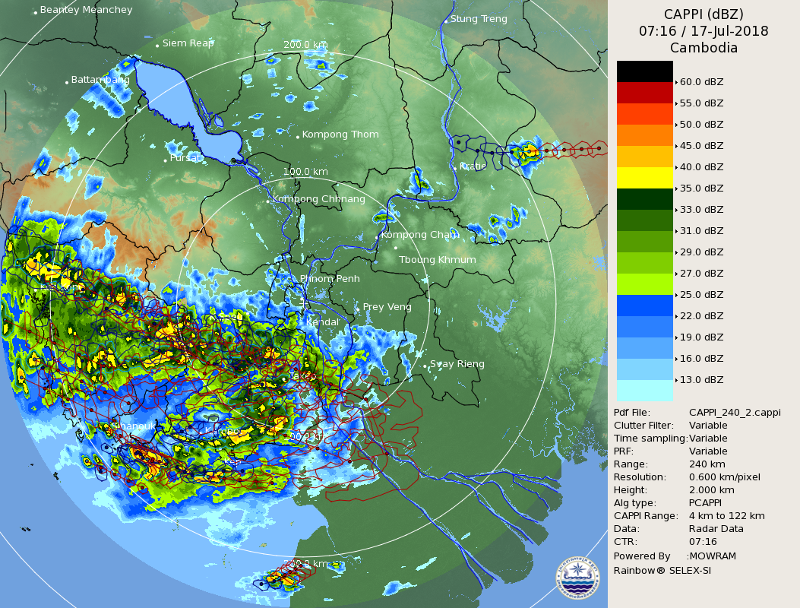

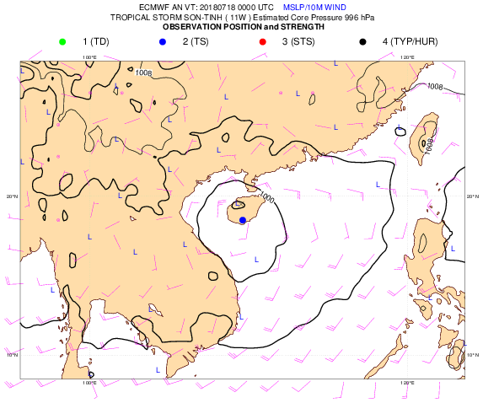

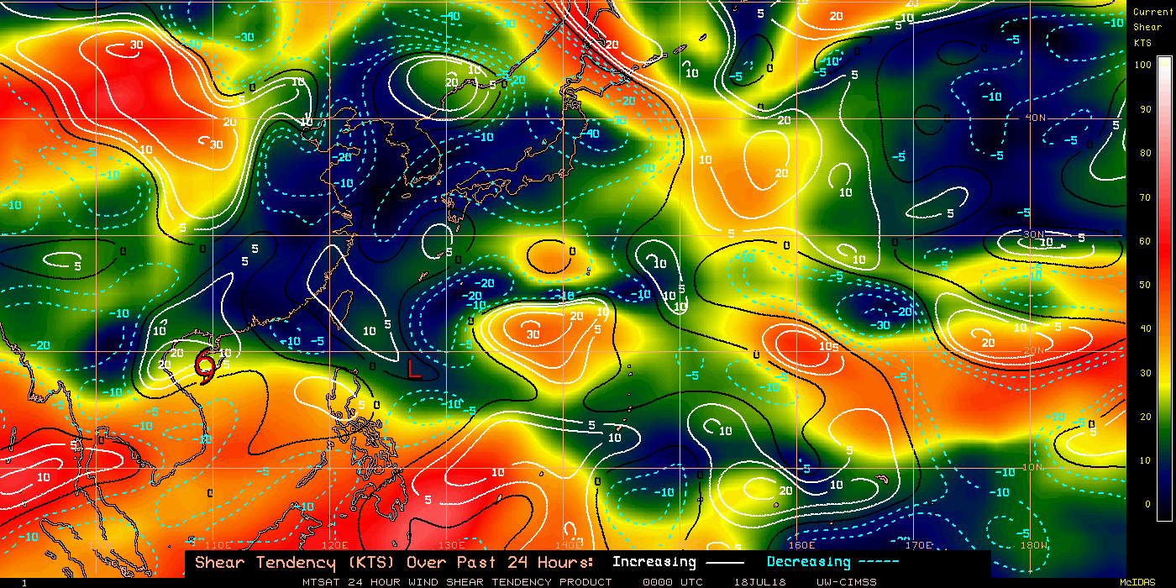

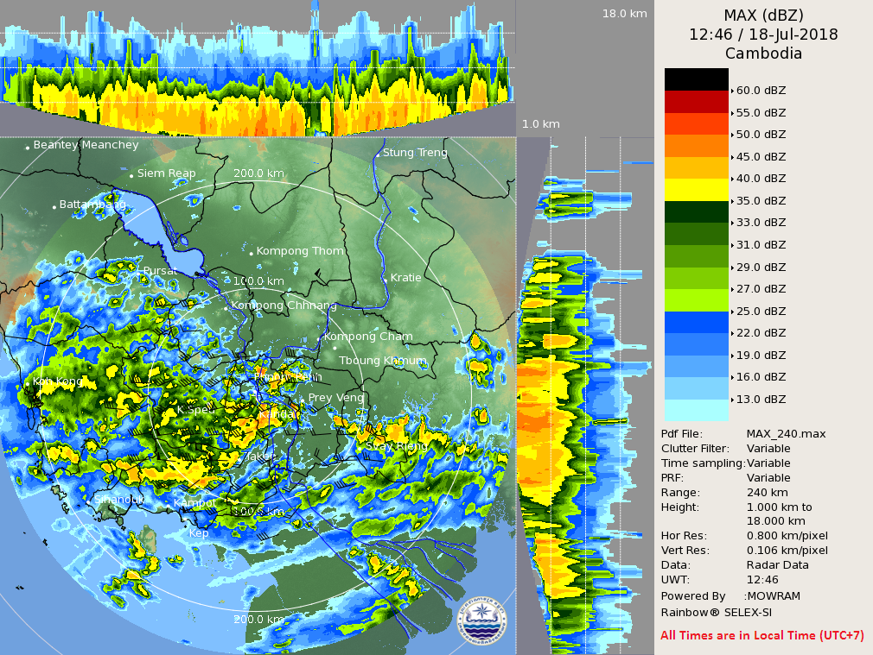

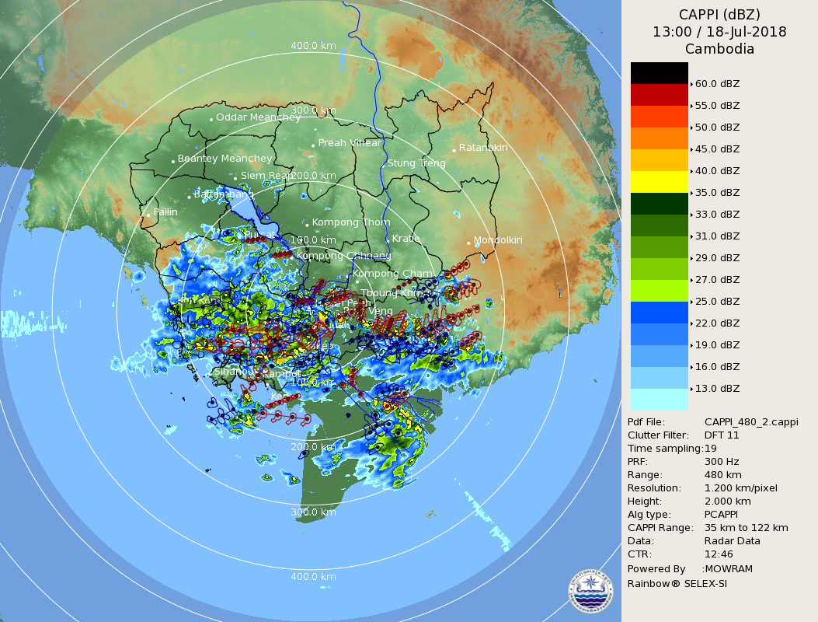

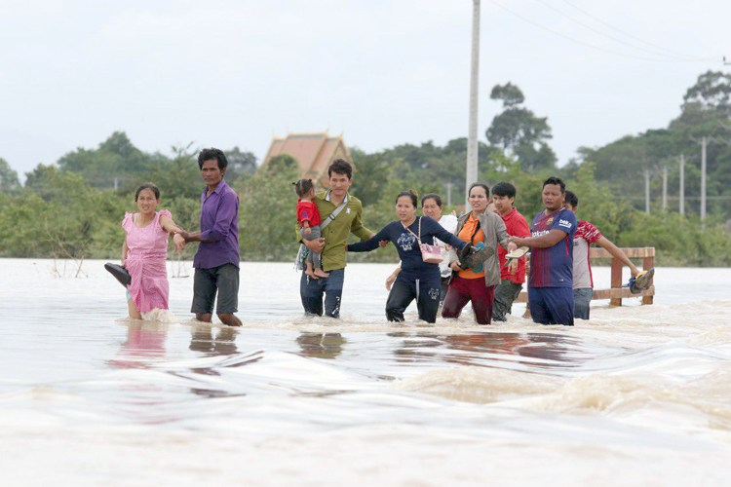Floods in Phnom Sruoch District in Kampong Speu Province, Cambodia, July 2018. Photo: Ministry of Information, Cambodia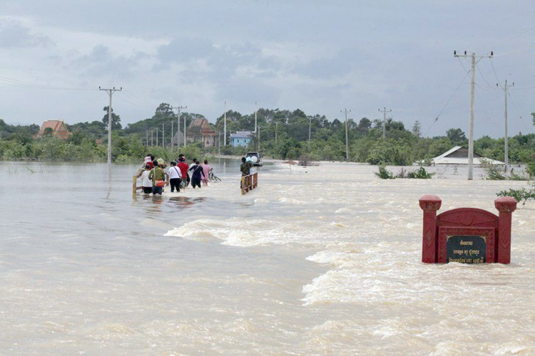Floods in Phnom Sruoch District in Kampong Speu Province, Cambodia, July 2018. Photo: Ministry of Information, Cambodia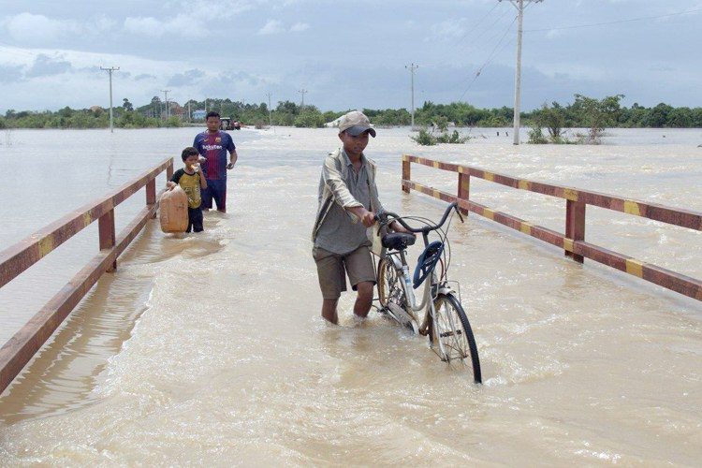Floods in Phnom Sruoch District in Kampong Speu Province, Cambodia, July 2018. Photo: Ministry of Information, Cambodia

### Related

[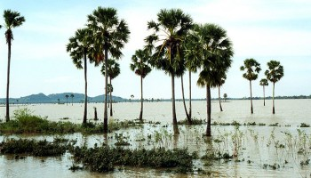](http://floodlist.com/asia/cambodia-floods-12-provinces)

#### [Cambodia - Floods in 12 Provinces, 20 Dead](http://floodlist.com/asia/cambodia-floods-12-provinces)

11 August, 2014

[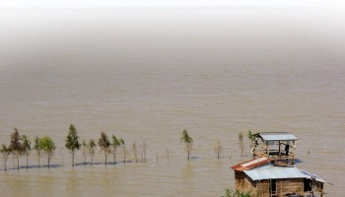](http://floodlist.com/asia/39-dead-cambodia-floods)

#### [39 Dead in Cambodia Floods](http://floodlist.com/asia/39-dead-cambodia-floods)

3 October, 2013

[](http://floodlist.com/asia/cambodia-floods-recede)

#### [Cambodia Floods Begin to Recede](http://floodlist.com/asia/cambodia-floods-recede)

18 October, 2013

[Breaking News](http://floodlist.com/tag/breaking-news)[Cambodia](http://floodlist.com/tag/cambodia)

26 JUNE 2018 Flash Flood in PP

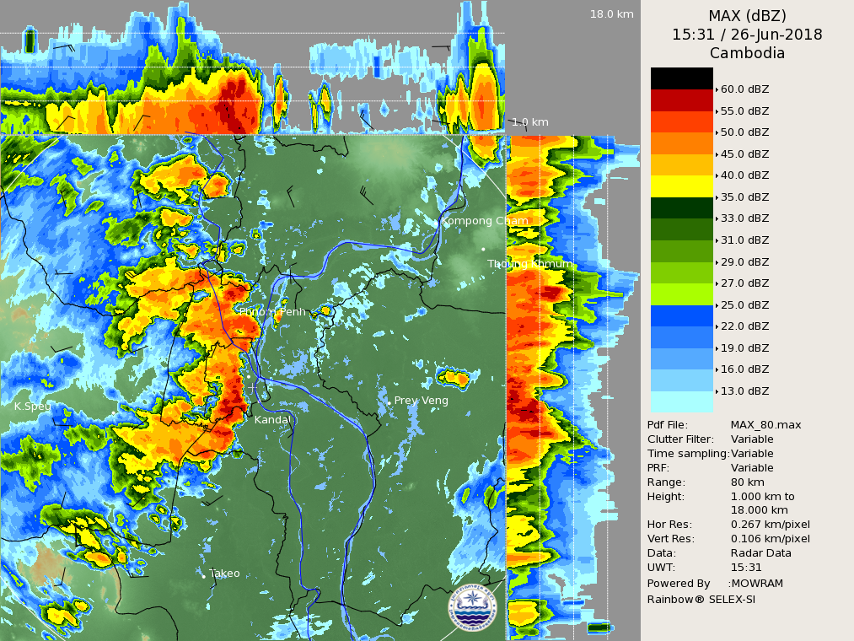

## Flooding hits road 4

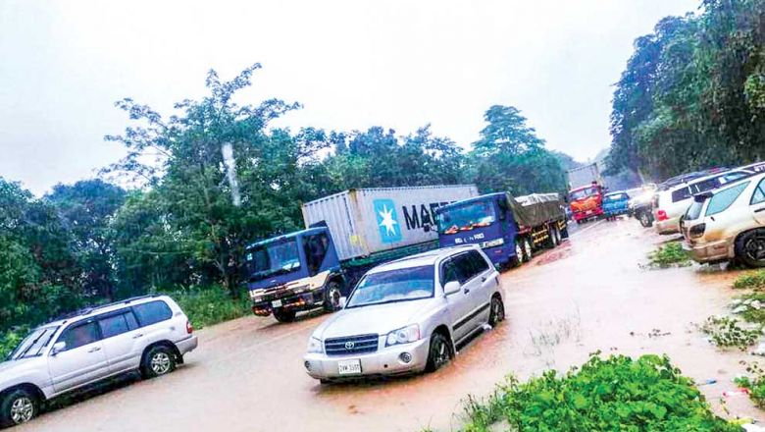

Traffic backs up on a flooded stretch of National Road 4 in Preah Sihanouk province on Tuesday. ministry of water resources

Flood levels in the Kingdom have been increasing due to rains over the last few weeks, causing issues across the country. Government officials, however, stayed with their claim that minor mishaps will be righted.

Monday night saw the closure of a bridge along Preah Sihanouk province’s National Road 4, due to rising waters.

Preah Sihanouk provincial Governor Yun Min said on Tuesday that water was receding slightly near the bridge, but still rising elsewhere in the province.

He said there was no major impact on the people’s lives because news had been received ahead of time.

Separately in Koh Kong province’s Thma Bang district, over 221 families were forced to leave their homes on Tuesday morning because of metre-high floodwaters.

The non-stop downpour caused floods in some areas such as the Tatey Leu commune, Thma Bang district, and some areas near the Cambodia-Thai border.

[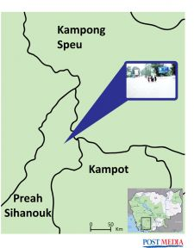](https://www.phnompenhpost.com/sites/default/files/styles/full-screen_watermarked/public/kampong-speu_sihanouk.jpg?itok=_X99jPgL)

Map by Post's Staff (Than Veasna)

On Sothearith, Thma Bang district governor told The Post that three to four villages near the Thai border were flooded.

“We are constantly ready and prepared to help the village people, but right now the flood has not caused any serious damage or harm to the people,” he said.

Chan Yutha, spokesman of the Ministry of Water Resources and Meteorology spokesman Chan Yutha told The Post on Tuesday that rising water levels were due to increased flows from water sources in Thailand. However, he expected that it will recede over the next several days.

Over in Stung Treng province, officials are carefully monitoring the Mekong water levels, especially near the Lower Sesan II dam.

Stung Treng Department of Water Resource and Meteorology director Pang Peng said the water height had reached 7.86 metres, still short of the 10.5 metres that call for emergency action.

“The Mekong River in Stung Treng can cause floods in the system of tributaries. But it should not cause worry,” he said.

The National Committee for Disaster Management’s spokesman, Keo Vy, said on Tuesday that those living along rivers, streams, canals or near the Thai border should be very careful.

Authorities additionally warned about the threat from high winds and rainfall during storms, highlighting the case of a capsized fishing boat off Preah Sihanouk province over the weekend.

The National Police website said three fishermen were rescued from the craft at around 7am.

It also noted that on Sunday, the body of another fisherman, identified as Hout Vanna, was found after having fallen into the water near Koh Doung Island.

-

## Factors that Influence Climate

There are lots of factors that influence our climate

**Elevation or Altitude effect climate**  
Normally, climatic conditions become colder as altitude increases. “Life zones” on a high mountain reflect the changes, plants at the base are the same as those in surrounding countryside, but no trees at all can grow above the timberline. Snow crowns the highest elevations.

**Prevailing global wind patterns**  
There are 3 major wind patterns found in the Northern Hemisphere and also 3 in the Southern Hemisphere. These are average conditions and do not essentially reveal conditions on a particular day. As seasons change, the wind patterns shift north or south. So does the intertropical convergence zone, which moves back and forth across the Equator. Sailors called this zone the doldrums because its winds are normally weak.

Latitude and angles of the suns rays  
As the Earth circles the sun, the tilt of its axis causes changes in the angle of which sun’s rays contact the earth and hence changes the daylight hours at different latitudes. Polar regions experience the greatest variation, with long periods of limited or no sunlight in winter and up to 24 hours of daylight in the summer.

**Topography**  
The Topography of an area can greatly influence our climate. Mountain ranges are natural barriers to air movement. In California, winds off the Pacific ocean carry moisture-laden air toward the coast. The Coastal Range allows for some condensation and light precipitation. Inland, the taller Sierra Nevada range rings more significant precipitation in the air. On the western slopes of the Sierra Nevada, sinking air warms from compression, clouds evaporate, and dry conditions prevail.

**Effects of Geography**  
The position of a town, city or place and its distance from mountains and substantial areas of water help determine its prevailing wind patterns and what types of air masses affect it. Coastal areas may enjoy refreshing breezes in summer, when cooler ocean air moves ashore. Places south and east of the Great Lakes can expect “lake effect” snow in winter, when cold air travels over relatively warmer waters.

In spring and summer, people in Tornado Alley in the central United States watch for thunderstorms, these storms are caused where three types of air masses frequently converge: cold and dry from the north, warm and dry from the southwest, and warm and moist from the Gulf of Mexico - these colliding air masses often generate tornado storms.

**Surface of the Earth**  
Just look at any globe or a world map showing land cover, and you will see another important factor which has a influence on climate: the surface of the Earth. The amount of sunlight that is absorbed or reflected by the surface determines how much atmospheric heating occurs. Darker areas, such as heavily vegetated regions, tend to be good absorbers; lighter areas, such as snow and ice-covered regions, tend to be good reflectors. The ocean absorbs and loses heat more slowly than land. Its waters gradually release heat into the atmosphere, which then distributes heat around the globe.

**Climate change over time**  
Cold and warm periods punctuate Earth’s long history. Some were fairly short; others spanned hundreds of thousands of years. In some cold periods, glaciers grew and spread over large regions. In subsequent warm periods, the ice retreated. Each period profoundly affected plant and animal life. The most recent cool period, often called the “Little Ice Age,” ended in western Europe around 1850.

Since the turn of the 20th century, temperatures have been rising steadily throughout the world. But it is not yet clear how much of this global warming is due to natural causes and how much derives from human activities, such as the burning of fossil fuels and the clearing of forests.

**II. Summary of Progress in Priorities supporting Key Result Areas**

1. [Activity or title of project and description]
2. [Activity or title of project and description]
3. [Add as many as needed]

**I. Overview of tropical cyclones which have affected/impacted**

**Member’s area since the last Committee Session**

1. **Meteorological Assessment (highlighting forecasting issues/impacts)**

[format unchanged from previous year. Please include any graphs, tables, images as necessary]

1. **Hydrological Assessment (highlighting water-related issues/impact)**

[format unchanged from previous year. Please include any graphs, tables, images as necessary]

1. **Socio-Economic Assessment (highlighting socio-economic and DRR issues/impacts)**

[format unchanged from previous year. Please include any graphs, tables, images as necessary]

1. **Regional Cooperation Assessment (highlighting regional cooperation success and challenges.**

[format unchanged from previous year. Please include any graphs, tables, images as necessary]

**II. Summary of Progress in Priorities supporting Key Result Areas**

1. **[Activity or title of project (in bold lettering)]**

**Main text:**

[Main text including description of event]

**Identified opportunities/challenges, if any, for further development or collaboration:**

[Describe opportunities and challenges]

**Priority Areas Addressed:**

[For this section please refer to the list of priorities as listed in the KRAs Table of the TC Strategic Plan 2017-2021. Please list no more than 5 priorities per activity or project.]

**Contact Information:**

Member: [Member]

Name of contact for this item: [Point of Contact]

Telephone: [Telephone Number]

Email: [Email Address]

1. **[Activity or title of project (in bold lettering)]**

**Main text:**

[Main text including description of event]

**Identified opportunities/challenges, if any, for further development or collaboration:**

[Describe opportunities and challenges]

**Priority Areas Addressed:**

[For this section please refer to the list of priorities as listed in the KRAs Table of the TC Strategic Plan 2017-2021. Please list no more than 5 priorities]

**Contact Information:**

Member: [Member]

Name of contact for this item: [Point of Contact]

Telephone: [Telephone Number]

Email: [Email Address]

1. **[Add as many sections as you need]**

EXAMPLE

1. **Tropical Cyclone Best-Track Announcement in 2015.**

**Main Text:**

KMA made an official announcement about the production of best-track data on the twenty-seven typhoons formed in the Northwest Pacific Ocean in 2015. KMA had independently developed the post-analysis system [Fig.2-2] and announced the best-track data on eight TCs which affected the Korean Peninsula in 2014 to 2015 on a trial basis [Fig.2-3]. Data shows errors in real-time analysis and the characteristics of climatological change of typhoons using post-analysis data on typhoon location, intensity, and size after the typhoon’s dissipation and is of great value for the objective verification with numerical model results. TC best-track data can also be utilized as criteria for typhoon preparedness. Besides, analysis techniques accumulated through the process of data production is expected to significantly improve the typhoon forecast.

**Identified opportunities/challenges, if any, for further development or collaboration:**

We intend to progressively produce Best-track data of recorded typhoons in the Northwest Pacific.

**Priority Areas Addressed:**

Enhance the capacity to monitor and forecast typhoon activities particularly in genesis intensity, and structure change.

Develop and enhance typhoon analysis and forecast technique from short to long term.

**Contact Information:**

Member: Republic of Korea

Name of contact for this item: Nam-Young KANG

Telephone: +82-70-7850-6355

Email: nkang.fsu@gmail.com